|  |  |
| --- | --- |
| **D:\CE\WhatsApp Image 2021-05-08 at 4.35.03 PM.jpeg**    ***“CULTIVATING EXCELLENCE IN EVERY STUDENT”***  **‘**  **RAKESH KUMAR**  **M.Sc. (Chemistry) B.Ed.**  **CTET, PSTET, HPTET qualified**  **thakurkumar82@gmail.com** |  |
| **Class:-XII (Sci.) Name of Student……………………**  **Subject:- Chemistry**  **10 year QuStions**  **Chapter-4**  **Chemical kinetics** |  |

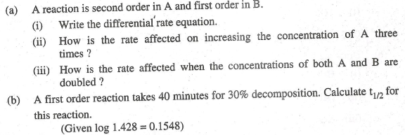

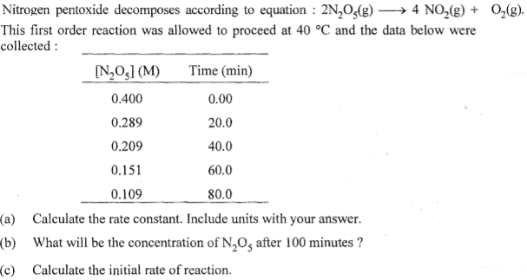

2. A first order reaction takes 20 minutes for 25% decomposition. Calculate the time when 75% of the reaction will be completed. (Given: log 2 = 0·3010, log 3 = 0·4771, log 4 = 0·6021)
3. 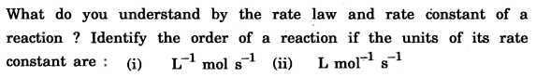
4. 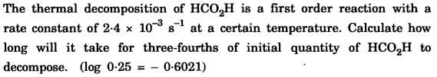

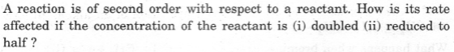

1. 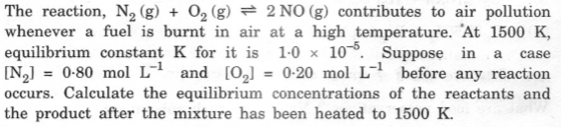
2. 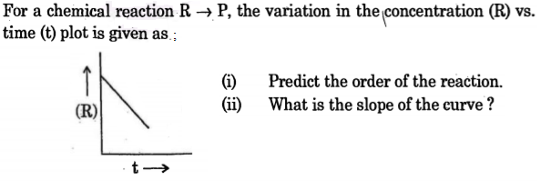
3. The following data · were obtained· during the first order thermal decomposition of SO2C*l*2 at a constant volume;

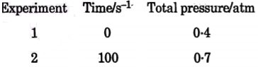

Calculate the rate constant. (Given: log 4 = 0·6021, log 2 = 0·3010)

1. For the hydrolysis of methyl acetate in aqueous solution, the following results were obtained:

t/s 0 30 60

[CH3COOCH3]/mol L–l 0.60 0.30 0.15

(i) Show that it follows pseudo first order reaction, as the concentration of water remains constant.

(ii) Calculate the average rate of reaction between the time intervals 30 to 60 seconds. (Given log 2 = 0.3010, log 4 = 0.6021)

1. (a) For a reaction A + B → P, the rate is given by Rate = k[A] [B]2

(i) How is the rate of reaction affected if the concentration of B is doubled?

(ii) What is the overall order of reaction if A is present in large excess?

(b) A first order reaction takes 30 minutes for 50% completion. Calculate the time required for 90% completion of this reaction. (log 2 = 0.3010)

1. The' rate' constant of a first 'order reaction increases from 2 x10-2 to 4 x 10-2 when the temperature changes from 300 K to 310 K Calculate the energy of activation (Ea);(log 2 = 0·301, log 3 = 0·4 771, log 4 = 0·6021)
2. Define rate of reaction. Write two factors that affect the rate of reaction.
3. The rate constant for the first order decomposition of H2O2 is given by the following equation:

Calculate Ea for this reaction and rate constant k if its half-life period be 200 minutes. (Given: R = 8.314 J K–1 mol–1)

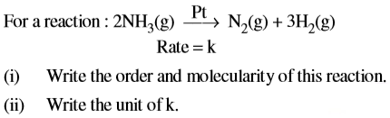

1. 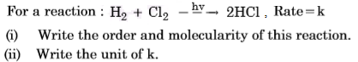

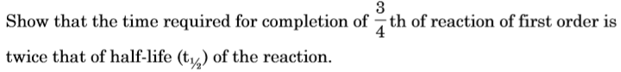

1. 

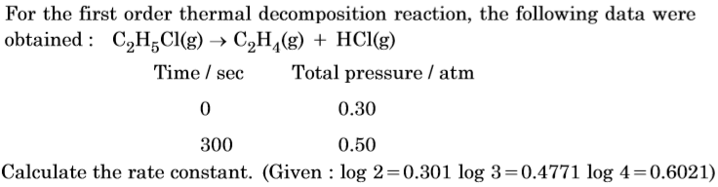

1. For a reaction R ––→ P, half-life (t1/2) is observed to be independent of the initial concentration of reactants. What is the order of reaction?

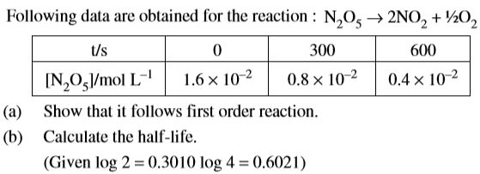

1. (a) A first order reaction is 75% completed in 40 minutes. Calculate its t1/2. (b) Predict the order of the reaction in the given plots :

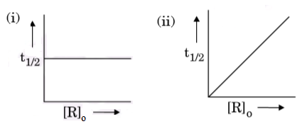

Where [R]o is the initial concentration of reactant. (Given: log 2 = 0·3010, log 4 = 0·6021)

1. The following data were obtained for the reaction : 2 NO + O2 → 2 NO2

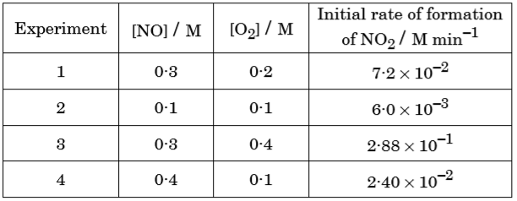

(a) Find the order of reaction with respect to NO and O2.

(b) Write the rate law and overall order of reaction. (c) Calculate the rate constant (k).

1. A reaction is first order in A and second order in B

(i) Write the differential rate equation.

(ii) How is the rate affected on increasing the concentration of B three times?

(iii) How is the rate affected when the concentration of both A and B are doubled?

1. The decomposition of NH3 on platinum surface is zero order reaction. If rate constant (k) is 4 × 10–3 Ms–1, how long will it take to reduce the initial concentration of NH3 from 0.1 M to 0.064 M?
2. For a reaction

The proposed mechanism is as given below:

(1) H2O2 + I– → H2O + IO– (slow) (2) H2O2 + IO– → H2O + I– + O2 (fast)

(i) Write rate law for the reaction. (ii) Write the overall order of reaction.

(iii) Out of steps (1) and (2), which one is rate determining step?

1. Define order of reaction. Predict the order of reaction in the given graphs :

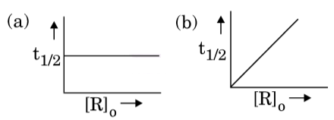

Where [R]o is the initial concentration of reactant and t1/2 is half-life.

1. The following data were obtained for the reaction : A + 2B → C

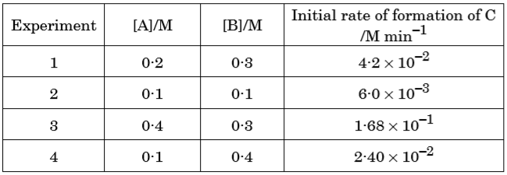

(a) Find the order of reaction with respect to A and B.

(b) Write the rate law and overall order of reaction. (c) Calculate the rate constant (k).

1. (a) Define order of reaction. How does order of a reaction differ from molecularity for a complex reaction? (b) A first order reaction is 50% complete in 25 minutes. Calculate the time for 80% completion of the reaction.
2. (a) The decomposition of a hydrocarbon has value of rate constant as 2·5 × 104 s–1 at 270C. At what temperature would rate constant be 7·5 × 104 s–1 if energy of activation is 19·147 × 103 J mol–1?

(b) Write a condition under which a bimolecular reaction is kinetically first order. Give an example of such a reaction. (Given: log 2 = 0·3010, log 3 = 0·4771, log 5 = 0·6990)

1. The rate of reaction quadruples when temperature changes from 293 K to 313 K. Calculate Ea assuming that it does not change with time. [R = 8·314 JK–1 mol–1]
2. (a) Draw the plot of ln k vs 1/T for a chemical reaction. What does the intercept represent? What is the relation between slope and Ea? (b) A first order reaction takes 30 minutes for 20% decomposition. Calculate t1/2. [Log 2 = 0.3010]
3. The reaction between A and B is first order with respect to A and zero order with respect to B. For this reaction, fill in the blanks in the following table.



